Thought Leadership Piece
For Immediate Release

Life Rights Explained: The Premier Global Retirement Model
The concept of Life Rights is quickly becoming the premier and predominant retirement model. This progressive approach to retirement, often referred to as the ‘right of occupation,’ is achieving significant acclaim in the United States, Australia, and New Zealand. In 2018, Rabie Property Group, launched its esteemed retirement brand, Oasis Life, which exclusively adopts the Life Rights model. John Chapman, Director at Rabie, unpacks the benefits of this scheme compared to a traditional Sectional Title ownership within the context of transitioning into retirement living.
The fundamental distinction between Life Rights and Sectional Title offerings hinges on the form of ownership. When you invest in a Life Right, you are securing a leasehold over a property, managed by the developer, which allows you to reside in your home for the entirety of your life or your partner’s life and you are fully protected by the Retired Persons Act.
One of the primary differences between investing in Life Rights rather than traditional property ownership is the management structure. In a Sectional Title development, homeowners manage the scheme themselves, which can lead to challenges as residents become less inclined to invest in infrastructural improvements and property maintenance as they age, resulting in disputes among body corporate members, particularly when unforeseen special levies are tabled. In contrast, with the Life Right model, the developer takes responsibility for the property in terms of common area management, and facilitates the process of structural maintenance and repairs needed in your home. This affords residents multifaceted benefits as the Life Right holder simply bares the responsibility for interior maintenance of the home.
In a retirement development adopting the Life Right model, as is the case with Oasis Life, the developer takes a long-term view on profitability and takes full responsibility for the success of the estate, ensuring the interests of the developer and Life Right holders are aligned. This is different to the view in a Sectional Title scheme where the developer sells out the development and hands it over to a Body Corporate or Home Owners’ Association. You’ll find that a reputable developer takes a committed and involved approach to a Life Rights based retirement village.
The majority of retirees seek financial security, as unforeseen expenses become a burden. The Life Rights model is financially beneficial to the retiree market due to is its predictability, allowing purchasers to meticulously plan for their future financial needs. As a Life Right holder you can enjoy the reliability of predictable costs, including upfront fee savings with no VAT or transfer duty applicable on sale or resale, predictable levy increases of CPI or 6% (whichever is greater), as well as freedom from the financial burden of unexpected special levies.
The process of selling or cancelling a Life Right is streamlined and advantageous compared to traditional property models. In typical scenarios, properties need to be sold by the heirs of deceased estates, often requiring renovations before sale. This process can be unpredictable and stressful, both in terms of timing and settling the final selling price. Investing in a Life Right provides you with far greater security and flexibility. For example, should you ever decide to relocate, your Life Right can easily be terminated. In the case of Oasis Life, we as Rabie Property Group will facilitate your resale, ensuring you or your estate receives 100% of the original purchase price, minus agent's fees of approximately 5% of the resale value. This approach provides a clearer forecast of what will be refunded to the deceased estate, all without the burden of property taxes on the resale.
Most people looking to invest in a Life Rights retirement village like Oasis Life have reached a transition phase in their life with more freedom and a means to travel. In their absence, residents benefit from complete peace of mind as their home is in safe hands with this kind of set up. The handling of all day-to-day aspects of the estate such as security, hospitality, maintenance, and gardening, provides residents with the freedom that comes with an ideal 'lock-up and go' lifestyle. It’s for this exact reason that any concerns about the expense of paying levies on top of municipal rates is nullified. Apart from Oasis Life Management taking care of all these day-to-day aspects, which includes the efficient running of the clubhouse and other amenities managed by the estate management, a unique and important feature of Oasis Life Management’s role that filters into the experience of this Life Right scheme is that the staff are hospitality trained to hotel standards. This means that there is a sincere commitment to delivering a positive experience for all residents.
In conclusion, when it comes to choosing your retirement lifestyle - investing in a Life Rights model is the ideal choice for retirees, offering a sense of security, financial predictability, and peace of mind. Life Rights delivers on its promise of lifelong residency, hassle-free property management, and a streamlined resale process, allowing retirees to embrace a free and fulfilling retirement lifestyle. It’s no surprise that with modern retirees wanting to keep the lifestyle they’ve earned in the form of a contemporary, hassle-free and hospitality-based experience, that globally the majority of people attracted to retirement estates based on the Life Rights model, is on the rise.
To experience luxury retirement living at its best, please visit www.oasislife.co.za and explore investment options.
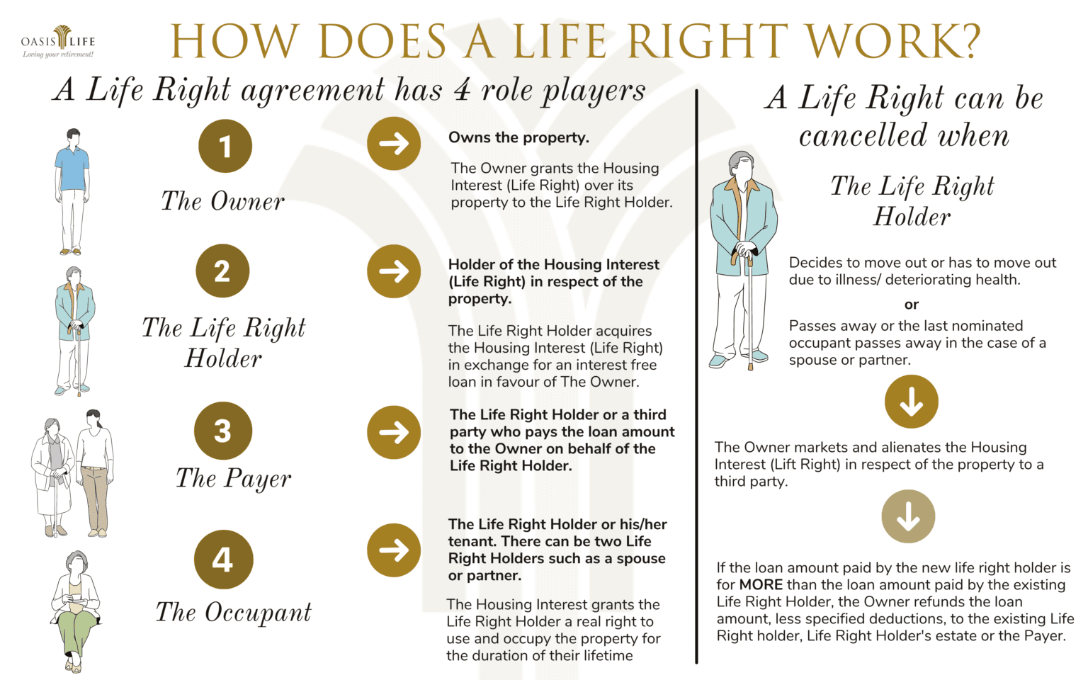
ENDS

Image Resource URL:
https://www.oasislife.co.za/life-rights-at-oasis-life-is-a-lifestyle-investment/#:~:text=Your%20investment%20is%20secure.&text=On%20termination%20of%20your%20life,take%20care%20of%20it%20all
Additional video by Oasis Life about Life Rights URL:
https://youtu.be/J36Sb6Jr2Kc?si=FGqLn8WYB0I-K_g2

Notes to the editor:
About the Author – John Chapman
John Chapman joined Rabie Property Group in 1988 and has vast experience in residential, commercial, and mixed-use development, ranging from urban planning to marketing. Chapman has been instrumental in many of the group's most successful and award-winning projects, including Century City, Dolphin Beach, West Lake, Big Bay, Royal Ascot, Fernkloof Golf Course in Hermanus, and more recently, Clara Anna Fontein and Burgundy Estate. Chapman is an advocate for contemporary and social, active retirement and has pioneered the growth of the Oasis Life retirement brand. The addition of Oasis Life to established mixed-use estates, such as Clara Anna Fontein, Burgundy Estate, and now the Bridgewater precinct with Ratanga Park at Century City, provides retirees with a double layer of security, allowing them to live, work, and play close to family and a wide variety of modern amenities nearby.
About Rabie Property Group
Rabie Property Group are an independent, Cape Town-based property development company operating predominantly in the Western Cape. Since being established in 1978, they have become one of South Africa’s leading property developers, creating new urban landmarks with their award-winning residential, commercial, and mixed-use developments, as well as their innovative marketing, and ground-breaking public private partnerships. They specialise in developing innovative living spaces for people and businesses looking for property in Century City and other parts of Cape Town.

For more information or visuals, please contact Janna Strang on janna@rainmakermarketing.co.za / 082 551 3865 or Tasha Thornton on tasha@rainmakermarketing.co.za

